

A Virtual Reality eLearning Authoring Tool Prototype – Application Set Up

Euan Macqueen

# Step 1

Go to <https://visualstudio.microsoft.com/vs/> and download Visual Studio Community 2019.

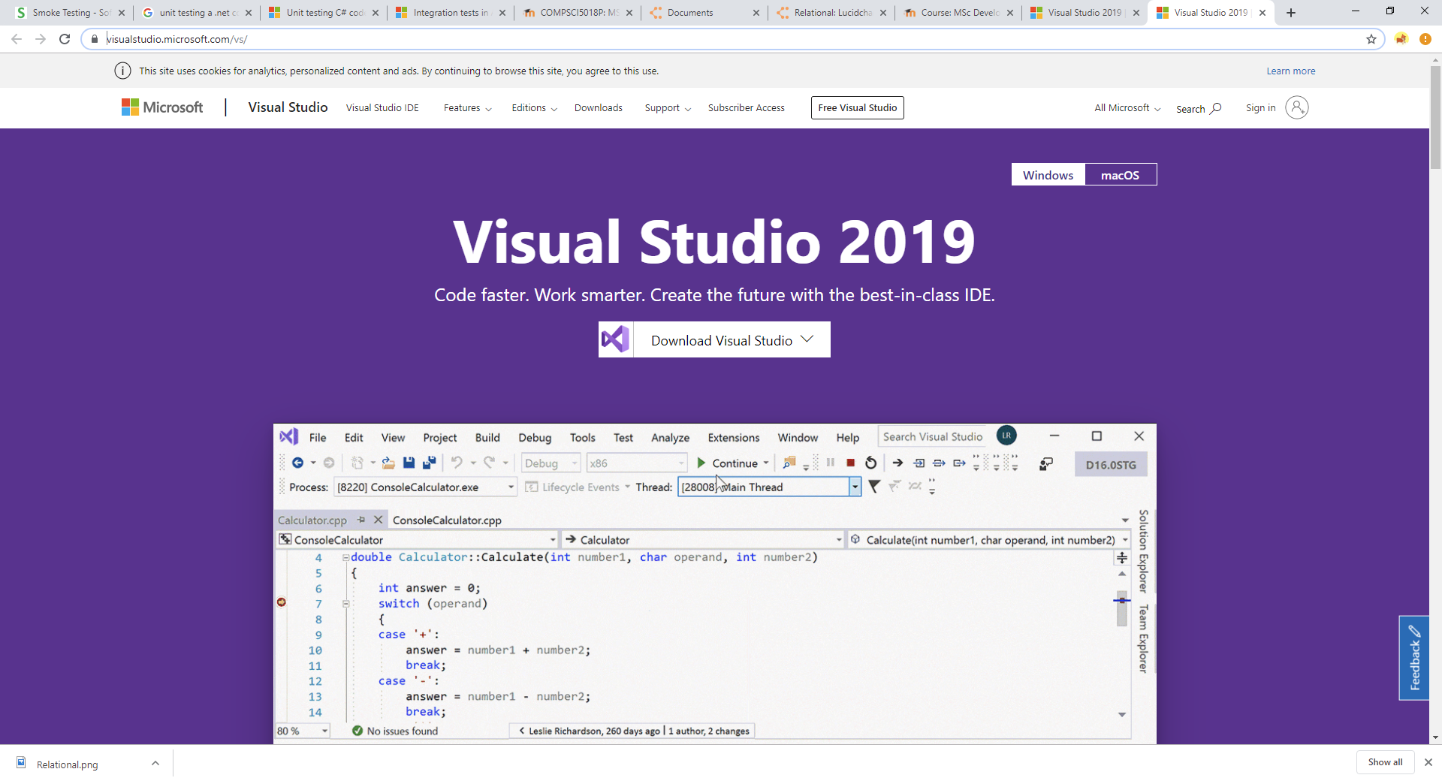

# Step 2

Once downloaded, run the installer.

# Step 3 – Workloads

When asked what workloads you would like to install, select ASP.NET and web development and Data Storage and Processing.

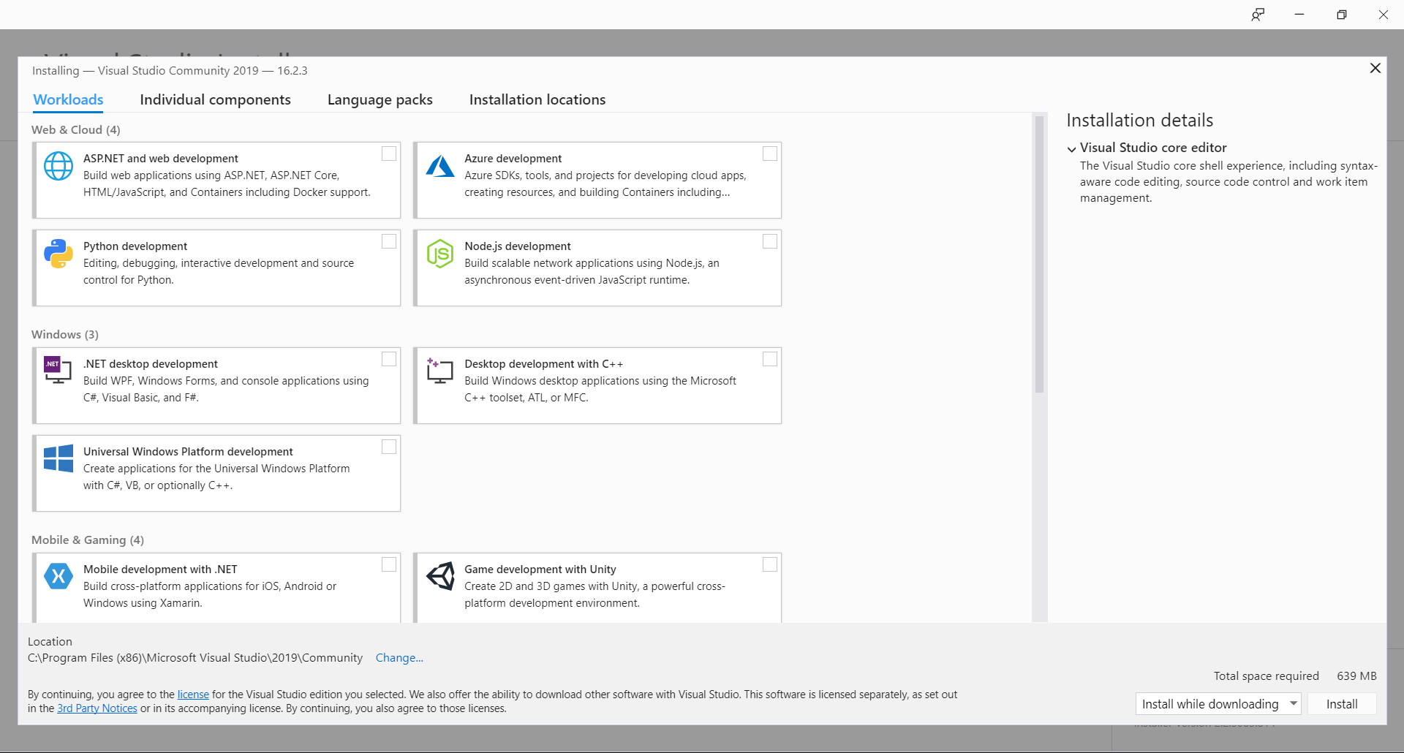

# Step 4 – Sign in / Log in

When presented with sign up or log in, select skip.

# Step 5 – Open ReaLearn

Once Visual Studio has installed, select “Open existing project or solution”

* Select ReaLearn_Core.sln

# Step 5 – Run

Select Run. ASP.net should install all dependencies required.

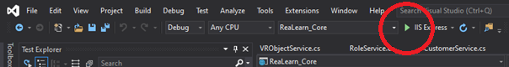

# Step 5 – Application Built and Running

Once the application has built and you are taken to the log in page. Register an account. Remember your username and password. Once you register, you will get a migration warning, this is just because the application hasn’t been built on your device. At the bottom of the page, select “apply migration.” Refresh the page, select continue to resubmit your post request to register your account.

# Possible Error – Asp.net version

If you encounter errors saying that asp.net 2.2 could not be found. Please go to

# <https://dotnet.microsoft.com/download/dotnet-core/2.2>

and download SDK 2.2.401’s .NET Core Installer: [x64](https://dotnet.microsoft.com/download/thank-you/dotnet-sdk-2.2.401-windows-x64-installer) | [x86](https://dotnet.microsoft.com/download/thank-you/dotnet-sdk-2.2.401-windows-x86-installer). Select whatever your device requires. Run the installer. Try and run the program. If you still get an error, uninstall the Asp.net CORE 2.1 or whichever version is not 2.2. Restart Visual studio. If problems persist, ensure all dependencies have been downloaded (this should be automatic but just in case). To install dependencies manually, right click the project ReaLearn_Core. Select “Manage NuGet Packages.” Under the Browse heading, search and install each dependency, as follows:

Bootstrap 4.0.0  
MailKil 2.2.0  
Microsoft.AspNetCore.App (2.2.0)  
Microsoft.AspNetCore.Http (2.2.2)  
Microsoft.AspNetCore.Razor.Design (2.2.0)  
Microsoft.jQuery.Unobtrustive.Ajax (3.2.6)  
Microsoft.VisualStudio.WebCodeGeneration.Design (2.1.9)  
Moq(4.13.0)

# Step 5 – Log in

Once returned to the log in page, log in with your username and password. You are now free to add a course on the dashboard, or you can go to the admin section of the navigation bar to manage your courses and users. You can now also access the scene editor.

# Further Steps

If you choose to create a scene and test the exported content. Please copy the folder “OPT” from the solution and paste into your C://   
The paths should be like so:

C:\OPT\DEFAULT  
C:\OPT\ZIPS  
C:\OPT\EXPORTS

Additionally, if choosing to export – you will need to update lines 216 and 217 in the ExportController class. The key and the secret are specific to your Rustici learning management account. Please follow <https://xapi.com/try-developer/> for details on how to set up the LMS and get your Key and Secret.

Please visit Rustici’s free cloud-based learning management system:

<https://rusticisoftware.com/products/scorm-cloud/>

From there, create a free account and upload your exported content as xAPI upload.

Note:

During development, this application always aimed to deploy. As deployment proved to be too difficult, audio and video assets are stored outside of the solution in the C:/ drive. Additionally, as the VR framework, ‘A-Frame,’ is only on version 0.9.2, there can be unexpected behaviour regarding scene loading and performance. If problems are encountered, simple refreshing the page will fix them.

Back up:

If there are any problems with the submission, please follow this GitHub link: <https://github.com/euanM108/2425291m_Msc_ReaLearn>

From there select “Clone or Download.” Select “Download as zip.” Once complete, unzip the folder. Complete step 5 onward opening the solution downloaded from GitHub.